Day 2: (task 2)
Basic DML Operations(Insert,Update,Delete,Lock,Call)
1.Input: (users Table)
orders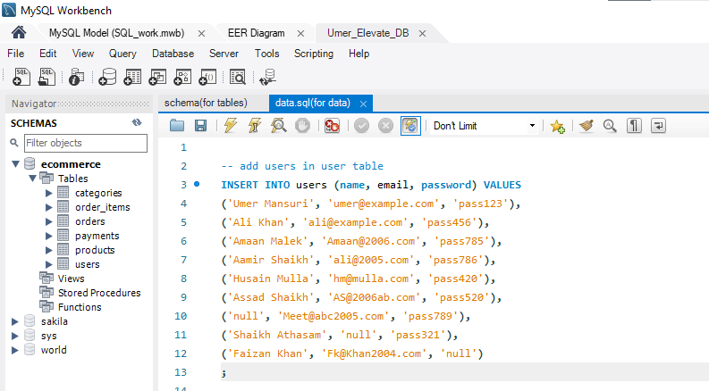
2.Input:(Categories Table)
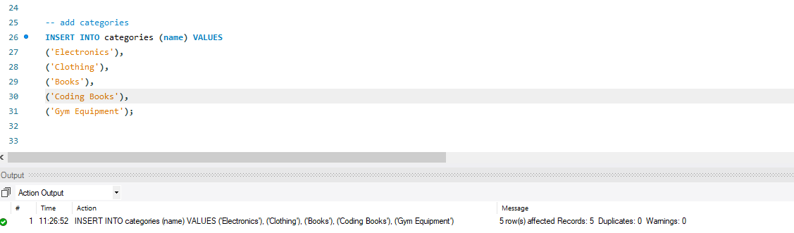

3.input: (products Table)
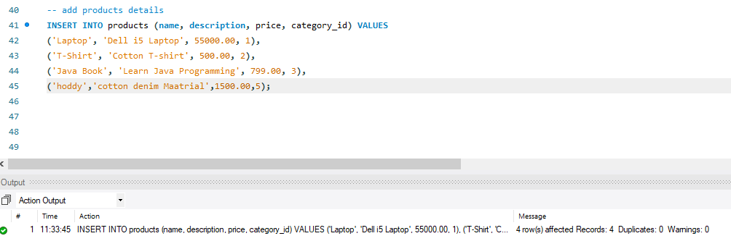
4. input: (Order Table)
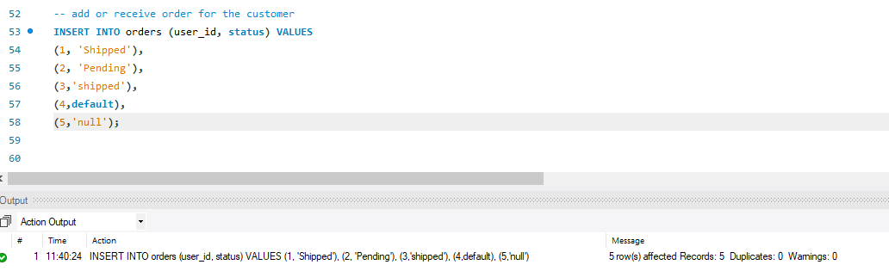
5. input: (Order_items Table)
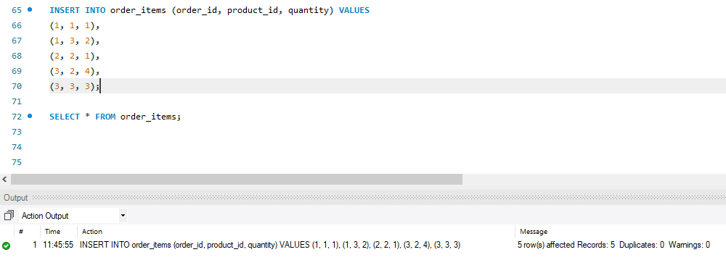
6. input: (Payments Table)
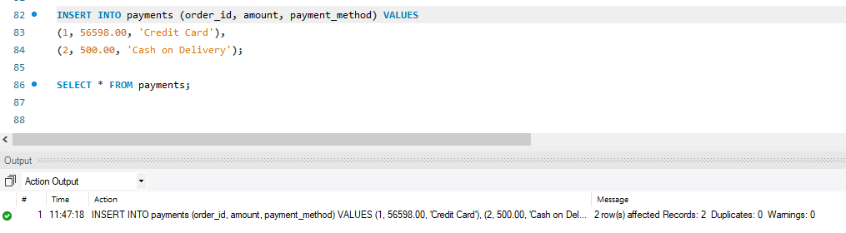

All Inserted data of all the tables:
Output:
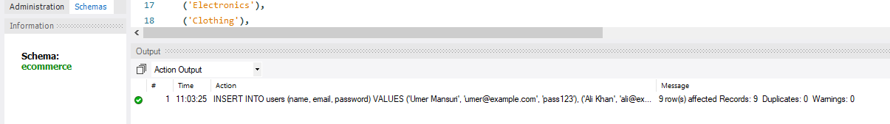
1.Insert data in users table: (with null values in specific column)
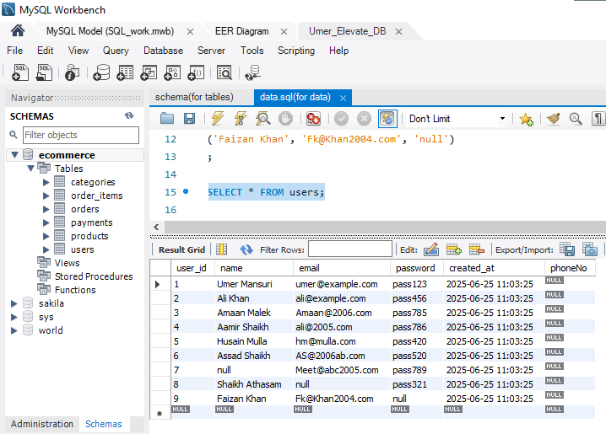
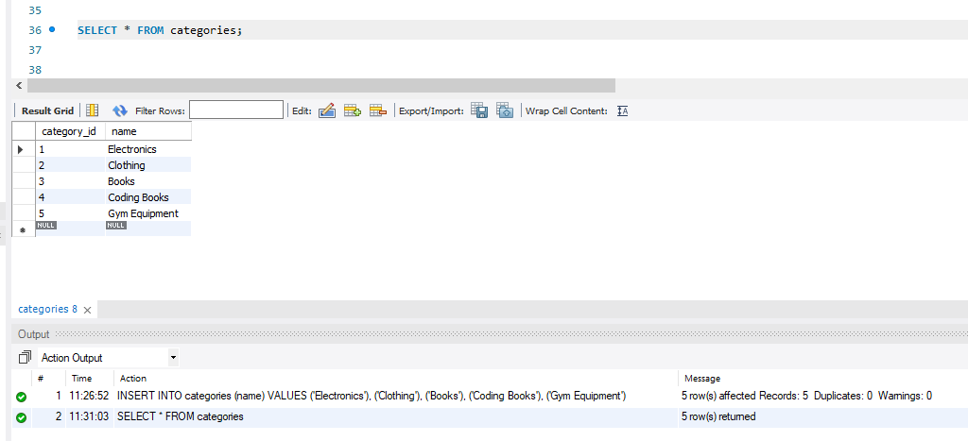
2.Insert data in Categories table:
3. Insert data in Products table:
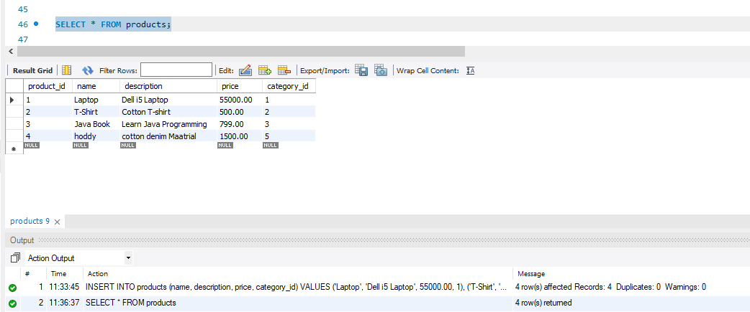
4. Insert data in Orders table:
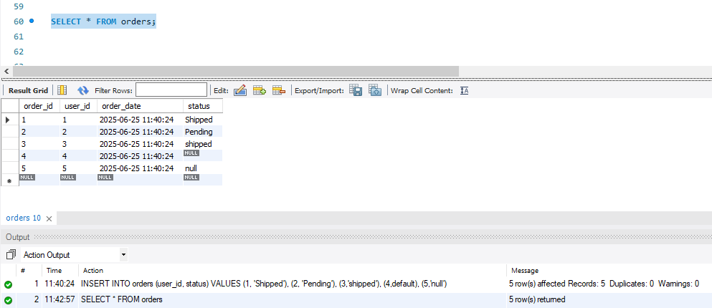

5. Insert data in Order_items table:
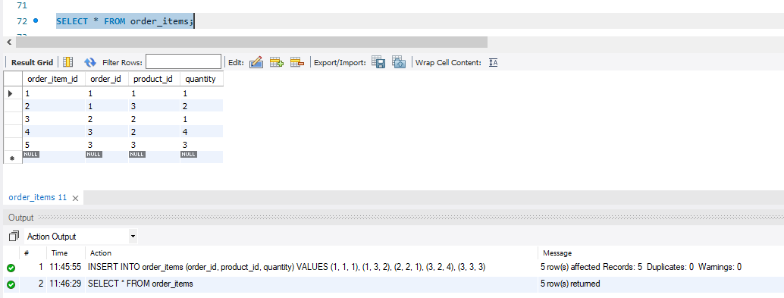
6. Insert data in payments table:
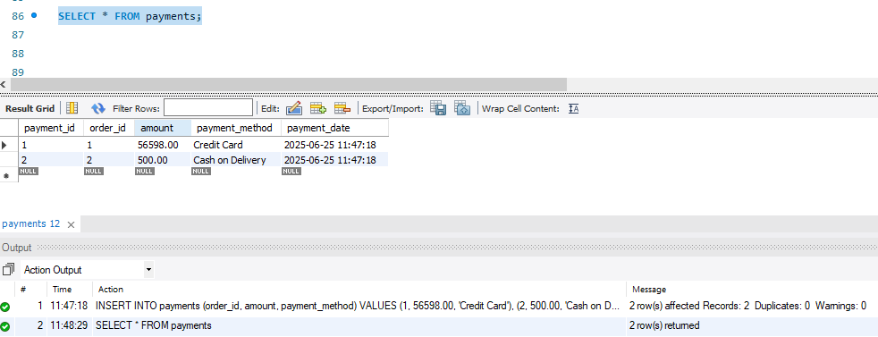

2. Update some specific data on the tables:
1. Update data in users tables: (use to update multiple column)
Output:
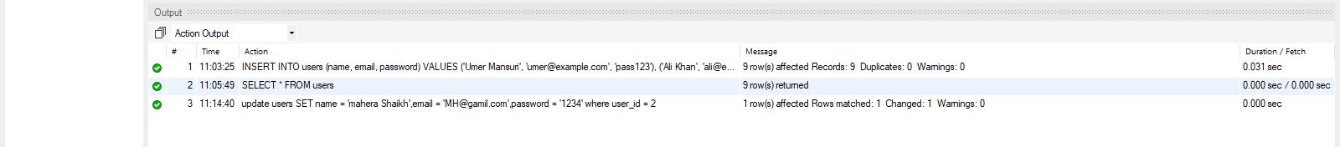
Updated in the user_id = 2 :
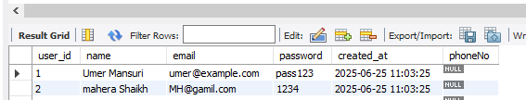
1.2. Update data in users tables: (use to update Single column)
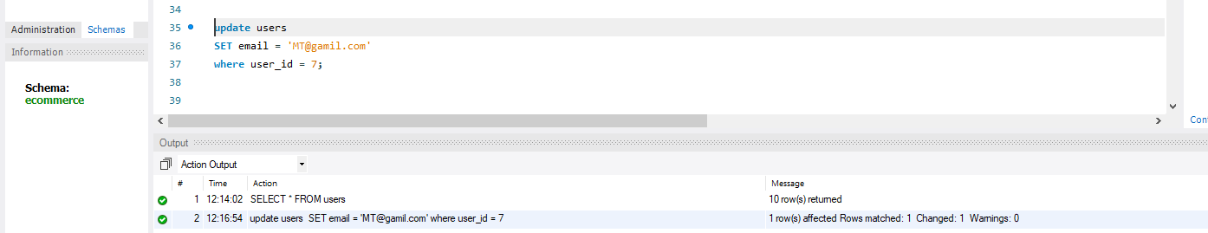
2. Update data in categories tables: (use to update Single column)
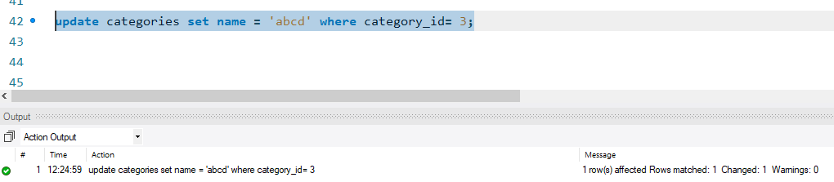
Output: (Update on category_id = 3)
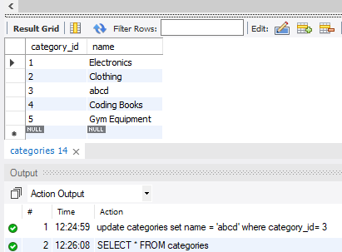
3. Update data in products tables: (use to update Single column)
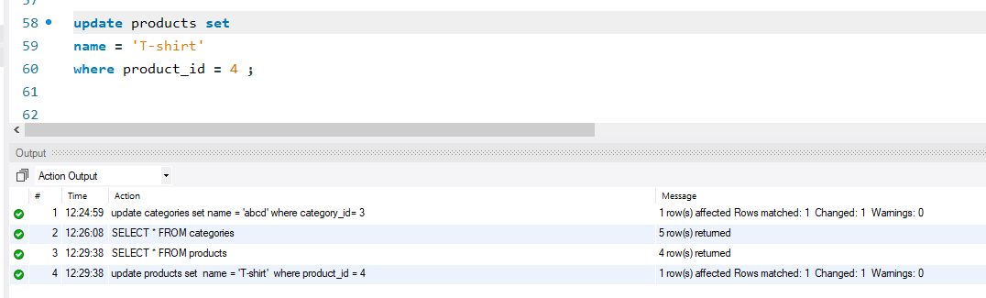
Use to update Multiple column:
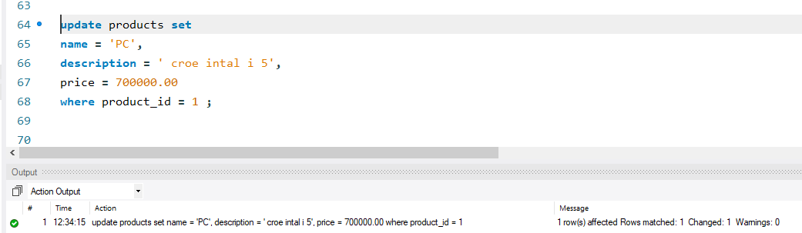
Output: (Update in the product_id = 4)(single column)
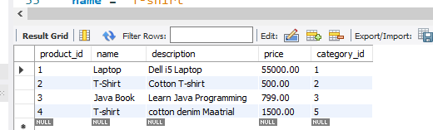
Output : (multiple column)
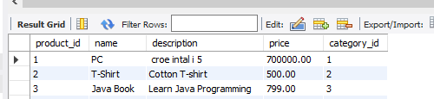

4. Update data in order tables: (use to update Single column)
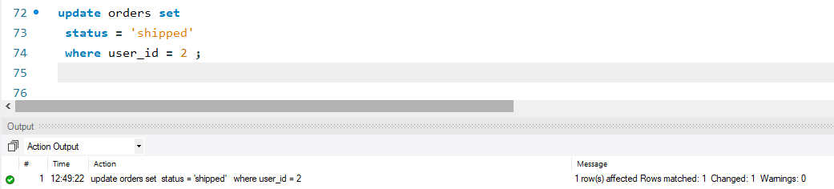
Output: ( Update in the user_id = 2)
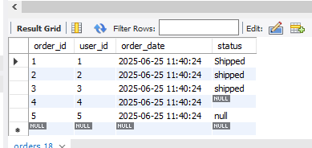
5. Update data in order_items tables: (use to update Single column)
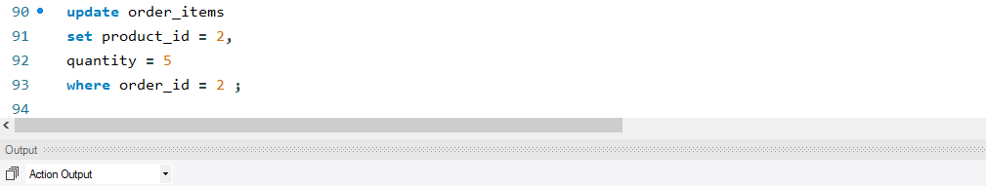
Output: (update in the order_items_id =3)
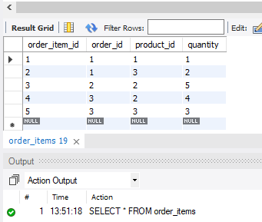

6. Update data in payments tables: (use to update Single column)
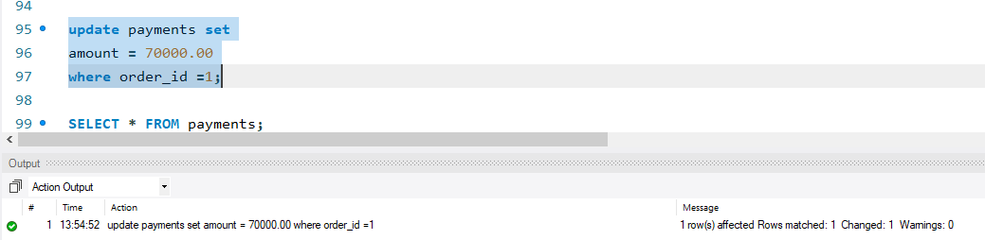
Output: (Update in first column of order_id = 1)
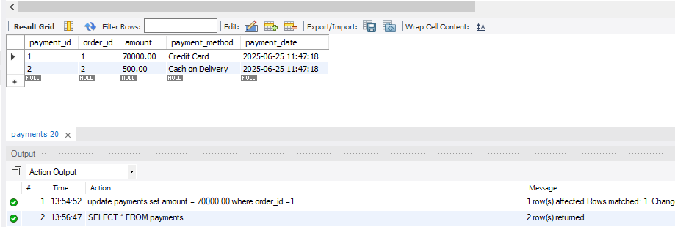

3. Delete data from tables:
1. Delete data from user table: (for single column)
Input:
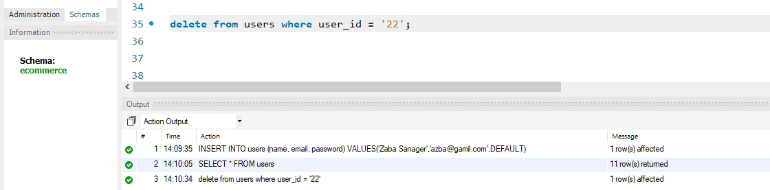
Output: (delete user_id = 22 )
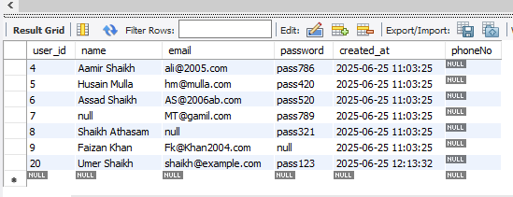
2. Delete data from order_items table:
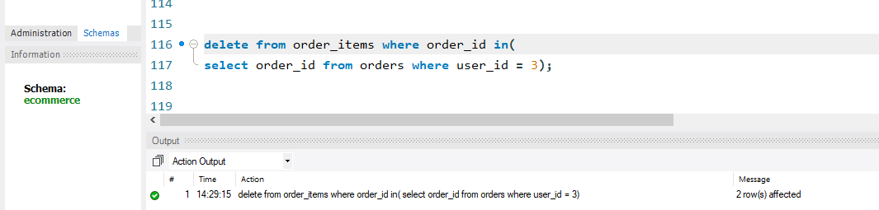
3. Delete data from payments table:
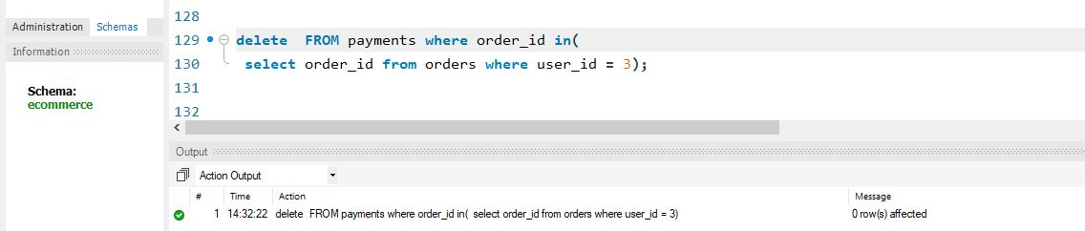

4. Delete data from orders table:
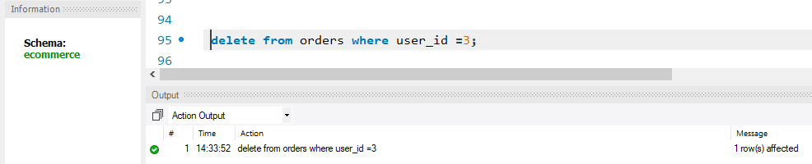
Delete all data from all tables:
Order: always delete child → parent
